

A PROJECT REPORT ON
MozGnowser

2009-2010 PROJECT REPORT SUBMITTED BY

Sai Srivatsan Iyengar (4992)
Jayakrishnan Nair (5018)
Ridima Borkar (5334)
Foram Dalal (5336)

UNDER GUIDANCE OF
Dr. G. Nagarjuna
(TIFR , Chembur, GNOWSYS LAB) and


Prof. Merly Thomas
Department of Computer Engineering
Fr. Conceicao Rodrigues College of Engineering


FR. CONCEICAO RODRIGUES COLLEGE OF ENGINEERING,
BANDSTAND, BANDRA (W), MUMBAI-400005

CERTIFICATE

This is to certify that
Sai Srivatsan Iyengar (4992)
Jayakrishnan Nair (5018)
Ridima Borkar (5334)
Foram Dalal (5336)

have satisfactorily completed the requirements of the
Term work of Project II
as prescribed by the
University of Mumbai

Project Guide Head Principal

(Mrs. MERLY THOMAS) (Computer Department)

This report has been examined by us as per the University requirements at

Fr. Conceicao Rodrigues College of Engineering, Bandra, Mumbai.

Internal Examiner External Examiner
ACKNOWLEDGMENT

"Great thoughts speak only to the thoughtful mind, but great
actions speak to all mankind."

At the outset, we offer our sincere thanks to respected and honorable Guide Dr. Nagarjuna G who granted us an opportunity to work at “TATA INSTITUTE OF FUNDAMENTAL RESEARCH” and who never hesitated to lend his invaluable Knowledge, support and cooperation, whenever we were in need of it. Our confidence in him is so immense that in the event of any difficulty we always relied on him.

We also wish to acknowledge sincere thanks to Mr. Rajiv Nair who has efficiently guided us with their helpful practical knowledge and experience for the development process of the project.

We impart special gratitude to our Principal Dr.Srija Unnikrishnan and Mr. B.R Prabhu the H.O.D of computer department who were a constant source of help and played an important role in the successful execution of the project.

We also appreciate Mrs. Merly Thomas our Project Guide who also put in lot of efforts in giving us the right guidance during the development process of the project. We also appreciate his eagerness and enthusiasm in encouraging us to develop our creative and technical ideas, which ultimately led to success of our project.

Our special thanks also to the non-teaching staff for their great support and kind cooperation to provide us with whatever we required for the project. We also thank our family and our friends for their support and good wishes for our project. Never to be forgotten, we thank God for granting us success in our efforts during the formation of the project.
INDEX

Sr. No | CONTENTS | Page No.
1 | Introduction | 6
1.1 | Institution Profile | 6
1.2 | GNU- Free Software vs. Open Source | 7
1.3 | GNOWSYS Specifications & Goals | 8
2 | An Overview | 12
2.1 | Problem Statement | 12
2.2 | Need for System Research | 12
2.3 | Scope for Research Work | 13
3 | Literature Review | 15
3.1 | GNOWSYS An Overview | 15
3.2 | GNOWSYS Architecture | 17
4 | Requirement Analysis | 22
4.1 | Feasibility Study | 22
4.2 | Development Environment And Technologies | 23
4.2.1 | Hardware Requirements | 23
4.2.2 | Software Requirements | 23
4.2.3 | Technologies Involved | 24
5 | DESIGN | 57
5.1 | UML Diagrams | 57
5.2 | Interface Design | 59
5.3 | Architechture | 63
6 | Testing And Maintenance | 65
7 | Bibliography | 70

1. INTRODUCTION

1.1 INSTITUTION PROFILE

The Tata Institute of Fundamental Research (TIFR) was established in 1945 at the initiative of Dr. Homi Jehangir Bhabha. It had a modest beginning at the Kenilworth site on Peddar Road, Bombay in 1945 and later moved to the Royal Yacht Club, Apollo Bunder until the buildings at the Navy Nagar Campus in South Bombay were ready in 1962. The Institute is proud to have produced many of the finest scientists of India who have been involved in seminal research in fields ranging from Mathematics, Biology, Chemistry, Computer Science, Physics and Science Education as well as some aspects of Public Health.
There are at present about 400 scientists in the Institute working in various disciplines grouped into three major schools: the School of Mathematics, the School of Natural Sciences and the School of Technology and Computer Science. Homi Bhabha Centre for Science Education (HBCSE) is a National Centre of the Tata Institute of Fundamental Research, Mumbai. The broad goals of the Centre are to promote equity and excellence in science and mathematics education from primary school to undergraduate college level, and encourage the growth of scientific literacy in the country.

The Centre’s research in Science, Technology and STME is informed by current perspectives in cognitive science, developmental psychology, history and philosophy of science and sociocultural aspects of science and education. Pre-PhD. programs in these areas as well as in research methodology serve to orient incoming students into STME research. The Institute is also actively involved in the field of educational research with a special emphasis on school level education as well as some aspects of public health. The Institute has several field stations and research facilities in different parts of the country.

Gnowledge Lab is physically located in Mumbai in India, and is a research and development laboratory of Homi Bhabha Centre for Science Education, Tata Institute of Fundamental Research, TIFR. The lab's focus is on structure and dynamics of knowledge networks. We develop, design and distribute software and share our research and developed material to the rest of the world. All the software and the documents are released under copyleft licenses for reuse and global participation. Free Software Movement is growing at an unprecedented pace influencing the way how science, software and other kinds of symbolic forms are created, published and distributed. This culture is often called the copyleft.

The Gnowledge Lab at Homi Bhabha Centre for Science Education have developed a new portal to build a "roadmap to knowledge." The collaborative platform lets users add concepts and dependency relations between the concepts and activities. The idea is that for learners to understand a concept, they should first grasp the underlying concepts and have accumulated certain experience by performing certain activities. GNOWSYS is a Project developed in the Gnowledge Lab. which is a GNU project and is dedicated to the free software community. GNOWSYS is conceived and authored by Dr. Nagarjuna G.

1.2 GNU- FREE SOFTWARE vs. OPEN SOURCE

Free software is a matter of the users' freedom to run, copy, distribute, study, change and improve the software. More precisely, it refers to four kinds of freedom, for the users of the software:
The freedom to run the program, for any purpose (freedom 0).
The freedom to study how the program works, and adapt it to your needs (freedom 1). Access to the source code is a precondition for this.
The freedom to redistribute copies so you can help your neighbor (freedom 2).
The freedom to improve the program, and release your improvements (and modified versions in general) to the public, so that the whole community benefits (freedom 3). Access to the source code is a precondition for this.
Free software does not mean non-commercial. A free program must be available for commercial use, commercial development, and commercial distribution. You may have paid money to get copies of free software, or you may have obtained copies at no charge. But regardless of how you got your copies, you always have the freedom to copy and change the software, even to sell copies. In the GNU project, we use copyleft to protect these freedoms legally for everyone. But non-copylefted free software also exists. “It's free software and it gives you freedom!”—more and louder than ever. Every time you say “free software” rather than “open source,” you help our campaign.
If you are interested in whether a specific license qualifies as a free software license, see the list of licenses at
http://www.gnu.org/licenses/license-list.html.
When we call software “free,” we mean that it respects the users' essential freedoms: the freedom to run it, to study and change it, and to redistribute copies with or without changes. The GNU General Public License, a license designed specifically to protect freedom for all users of a program. Nearly all open source software is free software; the two terms describe almost the same category of software. But they stand for views based on fundamentally different values. Open source is a development methodology; free software is a social movement. Another misunderstanding of “open source” is the idea that it means “not using the GNU GPL”. It tends to accompany a misunderstanding of “free software”, equating it to “GPL-covered software”. These are equally mistaken, since the GNU GPL is considered an open source license, and most of the open source licenses are considered free software licenses. For more info on “Open Source Software” visit

http://opensource.org/licenses

1.3 GNOWSYS Specification and Goals

GNOWSYS is an acronym for Gnowledge Networking and Organizing System. It was conceptualized and launched as a project by Dr. G. Nagarjuna (HBCSE-TIFR).The 'G' in GNOWSYS is pronounced hard just as the 'G' in GNU. It is a web-application with unique features that make it only one of its kind. It is developed as a application using Plone CMF running on a free (as in freedom) webapplication server, ZOPE (Zee Object Publishing Environment), and is implemented in a versatile, full-featured object-oriented programming language Python. It currently uses PostgreSQL for storing the Gnowledge. Currently its development is supported by the Gnowledge Laboratory at Homi Bhabha Centre for Science Education, TIFR.
GNOWSYS is a GNU project (since December 2004).

http://www.gnu.org/software/GNOWSYS/

License:
GNOWSYS is free software; you can redistribute it and/or modify it under the terms of the GNU General Public License as published by the Free Software Foundation; either version 2 of the License, or (at your option) any later
The websites made with GNWOSYS create hyperlinks with names, unlike the monotonous hyperlinks present in the current web pages. That is, two resources not only have a link between them, but we also know the nature of the link. The nature of the link is available to both the software agents’ browsers. This results into a highly expressive semantic links, making Internet a true knowledge base. Since most of the organization is publishable explicitly, unlike the hidden order of the relational databases masked by the CGI in the present web sites the GNOWSYS website provides as accurate representation of the system as expressible.

This does not mean the objects cannot be protected. All published objects are owned by some user or the other, or grouped together. The objects can be tagged as public or private. Thus the system provides access to authenticated users only, and with a provision to specify what part of the system is available to anonymous users. While users are working on the Internet, their actions regularly contribute to the growth of the shareable cultural assets effortlessly. GNOWSYS, therefore, can not only help making and managing Web 2.0, but can take it beyond.

Applications of GNOWSYS:

1.] GNOWSYS is implemented as a web application server at Homi Bhabha Centre for Science and Education-TIFR.

2.] The Self Platform or the beta.selfplatform.eu uses GNOWSYS as a web platform for building online courses or tutorials and thus contributing to the cause of Knowledge sharing.

Key Features:
It is an object oriented database with each object provided by an unique URL. It is a web application server

It can store both data and meta data of objects. Objects can be classified according to subclass/ superclass relation, and also instantiation relation (class instance). Polymorphism is possible.

Objects and their classes (called Object Types) can be related in terms of arbitrary relation names. Metatype (type of types) and relations among them can also be expressed. Data and metadata of objects can be indexed in a catalog for faster query.

Optionally data can remain anywhere on the Internet keeping only the metadata in the database. This feature will be most useful for what is now becoming popular as semantic web.

Surrogates of procedures (classes, functions, and system calls) can also be installed in the database as special objects. (Any procedure callable through Python is supported.) These procedures execute when invoked as web services.

Using the above feature it is possible to design applications without writing program in any programming language: i.e., specifying the semantics of a program and mapping the elements of the program to the surrogates of procedures is sufficient for GNOWSYS to test the application design.

This forms the foundation for semantic computing using GNOWSYS.
It will also have a feature to store rules/constraints to facilitate inference and
formal model building. (under development)

Its data exchange subsystem will provide translation to and from various standard knowledge representation schemes such as CL (common logic), PetriNets, KIF (knowledge interchange format, CG (concept graphs), OWL (web ontology language), XTM (XML Topic Maps), etc.

Data can be accessed through HTTP, FTP, WebDav, XMLRPC protocols. GQL: Gnowledge Query Library is being developed for query, retrieval, and management of the DB. Presently it is implemented in XMLRPC.

It is interoperable. Works in all the known operating systems where both Python and Zope are known to work. Design

2. OVERVIEW

2.1. Problem Definition

Gnowsys works as single networked database that links a vast spectrum of knowledge from fields and are made easily accessible to one and all. Gnowsys stores a huge knowledge base that consists of Semantics & relationships among this data is added to the knowledge base using the logic of propositions created using subjects & predicates all in the form of Ontologies.
The Gnowsys Servers when connected across a Distributed Network will require a system that will facilitate the Knowledge in Gnowsys Servers to be accessible and shareable via the Internet. The MozGnowser Mozilla Firefox Extension will enable knowledge in the Gnowsys database to be accessed by users and shared via internet. It will provide a user friendly interface to search and manipulate data on the Gnowsys Server.

2.2 Need for System Research

As world is stepping into the next reign of Internet where semantics of communications play vital role in generating the information that we want from the internet, and this is only possible when computers can understand the semantics and are able to communicate among themselves in order to arrange and generate the information as when required.

GNOWSYS (Gnowledge Networking and Organizing System). GNOWSYS is a system to specify, publish and query about multiple logics, ontologies, and epistemologies. Its kernel includes three semantic layers with increasing order of semantic specification, three groups of component classes for storing objects of various complexity in the knowledge base, and three levels of generality with objects belonging to tokens, types and metatypes. It is specially made for publishing vocabularies, propositions, ontologies, complex systems, web services, with or without formal annotation.

So keeping this vision in mind GNOWSYS has been developed where data in collected and re-arrange in a manner, similar to how humans do relate things in their life. This is done by re-arranging the data in form of nodes, links and establishing relationships among them giving them an ontological. This form of data stored in GNOWSYS is very complex where relations among nodes and their attributes are established.

The Objective GNOWSYS is to build flexible and extendable conceptual schemes of storing and organizing such Knowledge and develop a server that stores, modifies, and distributes across the Internet. Its main objective is to publish any knowledge representation scheme with or without constraints in an object oriented distributed database.
To enable various GNOWSYS Systems to share Gnowledge across the Internet in a distributed fashion we need to develop a service that will enable information sharing by Replication and Migration of the semantic specification of the stored objects between distributed GNOWSYS Systems.

The Gnowsys Mozilla Firefox Extension will enable users an easy access to the Gnowsys database. This extension will provide a very user-friendly environment for the users to work on. Through the help of this extension users can even update the database regarding a certain knowledge domain by adding/removing objects, relations, attributes etc.

2.3 Scope of the Research work

Gnowsys Mozilla Firefox Extension will enable users to access the Gnowsys database across the internet regardless of the operating system used. The application can be used for web based knowledge representation and management projects, for developing structured knowledge
bases, as a collaborative authoring tool, suitable for making electronic glossaries, dictionaries and encyclopedias, for managing large web sites or links, developing an online catalog for a library of anything including books, to make ontology’s, classifying and networking any objects transactions can be unified etc..

Data can remain anywhere on the Internet keeping only the metadata in the database. This feature will be most useful for what is now becoming popular as semantic web. The Gnowledge server stores knowledge-base which is distributed across ‘n’ places over the Internet.

Information in the Servers are stored as Database Objects. Whenever an object is not found in Gnowledge server database the request is directed to nearest Gnowledge server for locating the required object. GNS server may send its IP address to secondary server as authentication of valid secondary server. This allows data to be fetched from any of the nearest server to the requesting client while the
server propagate request across many Gnowledge server using P2P infrastructure.

Downloading data across Gnowledge servers will not require authentication but heavy data operation like updating data on other servers or Backup(possible only based on Node hierarchy ,knowledge is propagated to the top node) will use PGP public key signature among servers. To Enable various GNOWSYS Systems to share Knowledge across the Internet in a distributed fashion we need to develop a service that will enable information sharing by Replication and Migration of the semantic specification of the stored objects between distributed GNOWSYS
Systems.

3. LITERATURE REVIEW

3.1 GNOWSYS An Overview

Before starting with the architecture of the system ,

We should know what the system actually is ?
And how it's going to be helpful to its users?

GNOWSYS is a GNU project (under active development) developed as an application of ZOPE (Zope Object Publishing Environment) taking advantage of storage in an RDBMS based database in PostgreSQL. The product is written in Python, a full featured object oriented programming language.
GNOWSYS is a distributed Gnowledge publishing system specially crafted for sharing digital resources among the users of Internet. It is implemented as a web application server. The digital resources can be documents, files, messages, lessons, links, programs, software libraries etc. Resources are shared by publishing them, writing about them, systematically organizing them, establishing named relations between them etc. Each resource once published acts as a web service. Thus, GNOWSYS is a software developed keeping in mind the emerging vision of Web 2.0 or Semantic Web. The knowledge collected by using GNOWSYS is encoded in a generic knowledge representation scheme so that it can be exported into standard semantic web encodings like OWL (Web Ontology Language), XML Topic Maps, CL (Common Logic), KIF (Knowledge Interchange Format etc.).The representation of knowledge happens in GNOWSYS using the following elements or organizers:
objects (available as meta type, object and object type)
attributes (available as attribute and attribute type)
relations (available as relation and relation type)
processes (available as process and process type)
systems (available as system and system type)
functions
classes & flows and users (available as users and user type)

All the information that is encoded in the system can be managed through its core interface, which is called GnowQL (Gnowledge Query Library).using this, the above elements can be added, edited, deleted, viewed.

How its going to be useful to its users ?

Each instance of GNOWSYS is a web application server publishing resources in the form of the elements mentioned above. Instances of GNOWSYS can talk to each other implicitly (transparently) in GnowQL after establishing peer to peer authentication. This enables the system to assert relations between both local as well as remote objects. The structure defined at one site can be made available as a template for another remote site. This enables reusability of patterns generated at one site in another. An ontology published at one site can be deployed at another site. The functions and classes provided by the libraries of programming languages can be published as web services, and they can be composed into programs and published as flow objects. Since these procedural objects can also be related to each other, a heterogeneous distributed computing platform can be created. This makes GNOWSYS a unique semantic computing platform providing transparent distributed heterogeneous semantic computing. All knowledge is collected as propositions published either as attributes or relations. By collecting or archiving the set of all attributes and relations expressed in the system, we collect all knowledge. The other elements act as organizers, while attributes and relations act as propositions. In other words, all other elements of GNOWSYS, apart from attributes and relations, act as frames helping us to navigate the knowledge base effortlessly. In another words, they act as nodes of a semantic network.

There are 10 node types in GNOWSYS, which are object type, attribute type, relation type, system type, process type, metatype, function type, flow type, class and user type. There will be two kinds of tables: node type tables, and the corresponding instance tables. Each node type instance points to a separate table; table name will begin with "[nodes]-nodetypeName"

Every nodetype has fields for storing the nodes with which each node has networking relations. The networking relations are called neighborhood nodes.

Each node type will have a field called 'subtypeof', and each node type will have a field called 'instanceof' except for the node type 'metatype';

Each node type will have a field called 'instances' referencing to the nodes that are instances of the node type. each node will have a field called 'instanceof'.

For each attribute type a corresponding attribute table will be created; e.g. for an attribute type named 'placeofbirth', a table called 'attributes-placeofbirth', so that all instances of a given attributetype will be stored in a specific table.

For each relationtype a corresponding relationtype table will be created; e.g. for a relationtype named 'brother-of', a table called 'relations-brother-of' will be made where all instances of 'brother-of' will be stored.

For each objecttype a corresponding object table will be created; e.g. for a objecttype named 'person', a table called 'person' will be created where all instances of 'persons' will be stored.

E.g., The 'object' tables will have the same structure of objecttype table except 'subtypeof' and 'instances' fields. Additionally the object tables will have a field 'instanceof', which stores the nid of the objecttypes as a FK. The total number of tables in GNOWSYS depends on the number of instances nodetypes+ nine nodetype tables.

3.2 GNOWSYS Architecture

GNOWSYS is an implementation-independent specification the knowledge base can be implemented in any database. The current implementation uses PostgreSQL, an object-relational database along with ZOPE which supports XML-RPC making GNOWSYS a web service. Metatype, usertype, objecttype, relationtype, attributetype, processtype, user, object, relation, attribute and process are the eleven classes that have been implemented in the recent version.

Storage Design: The tables used for storage can be divided into three parts: value tables, snapshot tables and some auxiliary tables.

Value Tables: Value tables are used to store the attribute values.

Snapshot tables: The eleven snapshot tables are namely gb-metatypes, gbusertypes, gbobjecttypes, gbrelationtypes, gbattributetypes, processtype, gbusers, gbobjects, gbrelations, gbattributes and process. The snapshot tables have the snapshot information, version information and the neighborhood properties .

Snapshot Fields: SSID, INID and UID are the snapshot fields. SSID is a unique id given to a node, INID is the nodeid and it is nothing but the first SSID and UID is the id of the user who is creating or modifying the attributes or relations of a node.

Version Fields: change number, commit number, changetype, history and fields changed are the version fields. These fields will be discussed in more detail in the section Version Control. neighborhood properties: attributetypes, attributes, relationtypes and relations are the neighborhood properties of a node.

Auxiliary tables: The following are the auxiliary tables Gbnidssid:
It stores the nid, INID, SSID and nodetype of all the nodes the knowledge base.
Gbnidlatestssid:
It stores the NID and the latest SSID of all the nodes in the knowledge base.
Gbregularexpressions:
The possible values that an attribute can have can be restricted on the basis of a regular expression stored in the gbregularexpressions table.

Gbvaluerestrictions:
This table is used to restrict an attribute value on the basis of it’s datatype, length, range, precision.
Gbselectionlist:
Some attributes may take values from a predefined list of values . This table stores information about such a list. For e.g. A list of languages, countries, levels recognized in a curriculum etc.

Version Control:
GNOWSYS is made for collaborative web based authoring of knowledge applying explicit semantics. In collaborative software development, hackers check out a development version from change management systems like cvs, svn, GNU arch, and make changes in a stand alone editor, and frequently make commits once they have reached a landmark. In this situation the version control system is required to have only the versions of various commits that each user makes. However, in the case of a collaborative web based authoring, the authors are generally using a client application (normally a browser), and each modification made can also be part of the history. This is a special requirement of the version management of web applications.
The knowledge base of GNOWSYS is complex, but follows a specified (predefined) structure. One aspect of the specification is that each node has a fixed number of fields in any given release of GNOWSYS. This feature enables us to define a version management scheme that manages to keep every change economically. The structured granularity will also be very useful in mirroring different instances of the knowledge base. Each node in the network has a neighborhood of nodes, and the specification clearly defines what kind of node will have what kind of objects in the neighborhood. For example, an object node will have the following fixed kind of objects in the neighborhood: relations, relation types, attributes, and attribute types. Maintaining versions of each node, and the metadata associated with each is a challenging task. The relevance of this feature is very high if the application is to be used as a community portal with collaborative work cycles.

Since GNOWSYS is particularly meant for sharing, collecting and distributing free knowledge, the following version management model emerged during its evolution.
The version properties of a node are as follows :

snapshotID (SSID): All changes to each node are stored in the history as snapshots (versions). Whenever any of the neighborhood properties are specified a new snapshot of the node is created. Thus each NID and INID can have multiple SSIDs.

Change Number: The field indicates the number of changes (updates) the node underwent after creation.
Commit Number: This records the number of times the node is committed by the user. Only committed snapshots would appear to other users.

Change Type: A node may undergo three types of changes creation, deletion or modication. elds changed Names of the network property elds that are affected while creating this snapshot.

History: This field gives the order of descendent nodes.

GNOWSYS ARCHITECHTURE

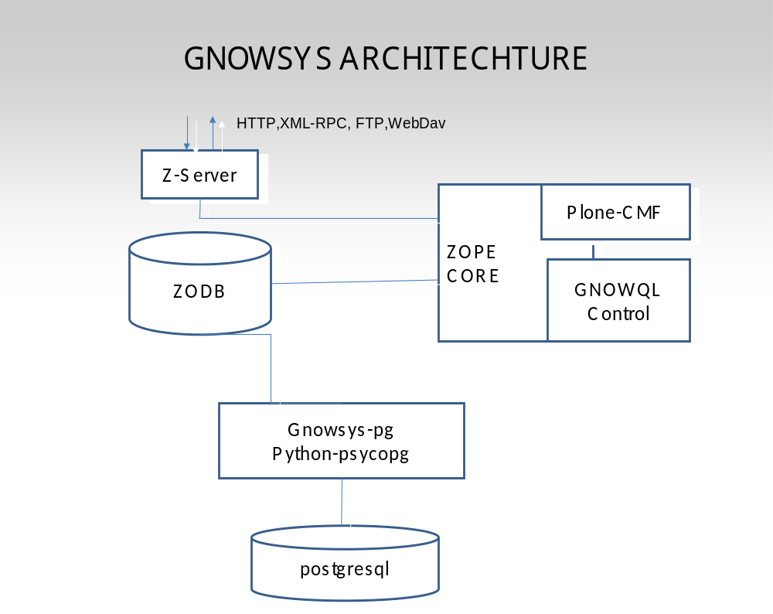

4. REQUIREMENT ANALYSIS

4.1 Feasibility Study

A feasibility study is a preliminary study undertaken to determine and document a project's viability. The term feasibility study is also used to refer to the resulting document. These results of this study are used to make a decision whether to proceed with the project, or table it.
The technologies used in this project are from the Free Software category which effectively cuts down the cost factor drastically.
- The technologies used in this project are from the Free Software category which effectively cuts down the cost factor drastically.
- The main idea behind implementing a project like MozGnowser is to make an extension for Mozilla Firefox such that people can search and manipulate data on the Gnowsys Server .

- By use of MozGnowser one can take advantage of the user friendly interface and can interact with the Gnowsys Server without any prior knowledge of internals of the Gnowsys system. This provides the community with a system that will enable Knowledge to be freely shared and distributed over the Internet. This emphasizes on the social feasibility factor.

- Economic feasibility of project can be settled for as GNOWSYS, is a free software web application for developing and maintaining semantic web content developed in Python. It works as an installed product in ZOPE. Here we can see that it is a Free Software Project under GNU avalaible for further development and contributions along with its free source distribution. All tools involved in development of project are free softwares.

- For further development of MozGnowser only basic knowledge of Python, Javascript, HTML, XPCOM and Gnowql (Gnowsys Query Library). As the extension is Mozilla dependent it gives it the advantage of working on all types of operating system where Mozilla Firefox can be installed. This states the Technical Feasibility of our project.

The security risk involved here is only related to the network the person will be using to connect to the Gnowsys Server.

4.2 DEVELOPMENT ENVIRONMENT AND TECHNOLOGIES

4.2.1 HARDWARE REQUIREMENTS:

SERVER SIDE CONGURATION:
Processor: Intel Core 2 Dual Processor / AMD 64
RAM: 1 GB (Minimum)
2 GB (Recommended)
Hard disk: 512 GB
Graphics : minimum of 64MB video memory

CLIENTSIDE CONFIGURATION:
Processor: Intel Celeron (Minimum)
RAM : 256 MB (minimum)
Hard disk: 40 GB (minimum)
Graphics: minimum of 32mb video memory
Internet Browser: Mozilla Firefox

4.2.2 SOFTWARE REQUIREMENTS:

Operating System: Any OS where Mozilla Firefox can be installed.
Language : Python , Javascript, HTML.
Server : Gnowsys Server
Packages: PyXPCOMext (http://pyxpcomext.mozdev.org/)
Front End: Mozilla Firefox
Back End : GNOWSYS

4.2.3 TECHNOLOGIES INVOLVED:

4.2.3.1 GNU/Linux based systems:

GNU s a computer operating system composed entirely of free software. Its name is a recursive acronym for GNU's Not Unix, which was chosen because its design is UNIX – like but differs from UNIX by being free software and by not containing any Unix code. GNU was founded by Richard Stallman and was the original focus of the Free Software Foundation (FSF). The GNU Project was launched in 1984 to develop a complete Unix-like operating system which is free software: the GNU system. Variants of the GNU operating system, which use the kernel called Linux, are now widely used; though these systems are often referred to as “Linux”, they are more accurately called GNU/Linux systems.
There really is a Linux, but it is not the operating system. Linux is the kernel: the program in the system that allocates the machine's resources to the other programs that you run. The kernel is an essential part of an operating system, but useless by itself; it can only function in the context of a complete operating system. Linux is normally used in a combination with the GNU operating system: the whole system is basically GNU, with Linux functioning as its kernel.
The project to develop GNU is known as the GNU project and programs released under the auspices of the GNU Project are called GNU packages or GNU programs. The system's basic components include the following:
GNU Complier Collection (GCC)
GNU Binary utilities (binutils)
Bash shell
GNU C library (glibc)
GNU Core utilities (coreutils).

4.2.3.2 GNU/Linux Distros:

A Linux distribution, often simply distribution or distro, is a member of the Linux family of Unix-like computer operating systems. Such systems are built from the Linux kernel and assorted other packages, such as the X Window system and software from the GNU project.
Because most (if not all) of the kernel and supporting packages are free and open source software, Linux distributions have taken a wide variety of forms from fully-featured desktop and server operating systems to minimal environments. Aside from certain custom software (such as installers and configuration tools) a "distro" simply refers to a particular assortment of applications married with a particularly compiled kernel, such that its "out-of-the-box" capabilities meets most of the needs of its particular end-user base.
There are currently over three hundred Linux distribution projects in active development, constantly revising and improving their respective distributions. One can distinguish between commercially-backed distributions, such as Fedora (Red Hat), SUSE Linux (Novell), Ubuntu (Canonical Ltd.) and Mandriva Linux and community distributions such as Debian and Gentoo. Usually, the procedures for assembling and testing a distribution prior to release are more elaborate as how big the user base of the distribution is.

4.2.3.3 Python:

Python is a dynamic object-oriented programming language that can be used for many kinds of software development. It offers strong support for integration with other languages and tools, comes with extensive standard libraries, and can be learned in a few days.Python is a remarkably powerful dynamic programming language that is used in a wide variety of application domain. Python is often compared to Perl, Ruby, Scheme or Java. Some of its key distinguishing features include:

- very clear, readable syntax
- strong introspection capabilities
- intuitive object orientation
- natural expression of procedural code
- full modularity, supporting hierarchical packages
- exception-based error handling
- very high level dynamic data types
- extensive standard libraries and third party modules for virtually every task
- extensions and modules easily written in C, C++ (or Java for Jython, or .NET languages for IronPython)
- embeddable within applications as a scripting interface

Why Python?
- Python is fast and very powerful:
Python lets you write the code you need, quickly. And, thanks to a highly optimized byte compiler and support libraries, Python code runs more than fast enough for most applications.

- Python has good compatibility with others:
Python can very well integrate with .NET and CORBA objects. For Java libraries the Jython is used which is an extension of Python for Java Virtual Machine.

- Python can run anywhere:
Python is available for all major operating systems: Windows, Linux/Unix, OS/2 etc. There are even versions that run on .NET, the Java Virtual Machine, and Nokia Series 60 cell phones. The most interesting point here is the code written in Python remains the same irrespective of the platform we run it on.

- Python is user friendly:
Python also comes with complete documentation, both integrated into the language and as separate web pages. Online tutorials are available for both the seasoned programmer and the newcomer. All are designed to make the user productive quickly. Also Python code is based on a minimalist approach. A ten line code in some other language like C++ can be completed in about 2-3 lines in Python thus reducing space and increasing the debugging capacity of the user.

- Python is Open:
Python implementation is under an open source license that makes it freely usable and distributable. It is the same even for commercial usage. The Python license is administered by the Python Software Foundation. Python being under the open source license is its biggest advantage as it is not bounded by any copyright issues and at the same time being widely used in commercial organizations like NASA.

4.2.3.4 ZOPE (Zee Object Publishing Server):

Zope is an open source web application server primarily written in the Python programming language. It features a transactional object database which can store not only content and custom data, but also dynamic HTML templates, scripts, a search engine, and relational database (RDBMS) connections and code. It features a strong through-the-web development model, allowing the user to update his web site from anywhere in the world. To allow for this, Zope also features a tightly integrated security model. Built around the concept of "safe delegation of control", Zope's security architecture also allows the user to turn control over parts of a web site to other organizations or individuals. The transactional model applies not only to Zope's object database, but to many relational database connectors as well, allowing for strong data integrity. This transaction model happens automatically, ensuring that all data is successfully stored in connected data sources by the time a response is returned to a web browser or other client.
There are numerous products (plug-in Zope components) available for download to extend the basic set of site building tools. These products include new content objects; relational database and other external data source connectors; advanced content management tools; and full applications for e-commerce, content and document management, or bug and issue tracking. Zope includes its own HTTP, FTP, WebDAV, and XML-RPC serving capabilities, but can also be used with the Apache or other web servers.

Zope users include Viacom, Boston.com, SGI, AARP, Bell Atlantic Mobile (now Verizon Wireless), Red Hat, NASA, the US Navy, I-Gift, GE, Verio, and Storm Linux.

Zope is an open-source software product with no software license fee. It takes advantage of object-oriented programming,making extension of existing applications easier.Third-party plugs-in can be developed that allow for rapid application development and integration. Zope ships with basic infrastructure that is needed in the development of Web applications and Websites. Basic Websites can be operational with minimal effort. It is also easy to integrate Zope-based applications with third-party products that minimize the development effort.

The open-source community supports and improves the available product and support options.

Benefits of Using Zope Application Server and Plone CMS

• Easy to install and thorough You can create a content-management system (CMS) very quickly and concentrate your resources on customization and design.
• Easy to use—The Plone team includes usability experts who have made Plone easy and attractive for content managers to add, update, and maintain content.
• International—The Plone interface has been translated into more than 20 languages and tools exist for managing multilingual content.
• Standard—Plone carefully follows standards for usability and accessibility. Plone pages are compliant with the World Wide Web Consortium’s(W3C’s) “AAA” rating for accessibility.
• Open source—Plone is licensed under the GNU-General Public License, the same license used by Linux. This gives you the right to use Plone without a license fee.
• Extensible—Plone offers a multitude of add-on products for new features and content types. In addition, it can be scripted using Web standard solutions and open-source languages.

The XML-RPC enabled object-methods’s in ZOPE can be taken advantage of by using Python xmlrpclib library ro communicate to the ZOPE application Server and get the data directly to clients in an heterogeneous network which has heavy application in semantic web services.

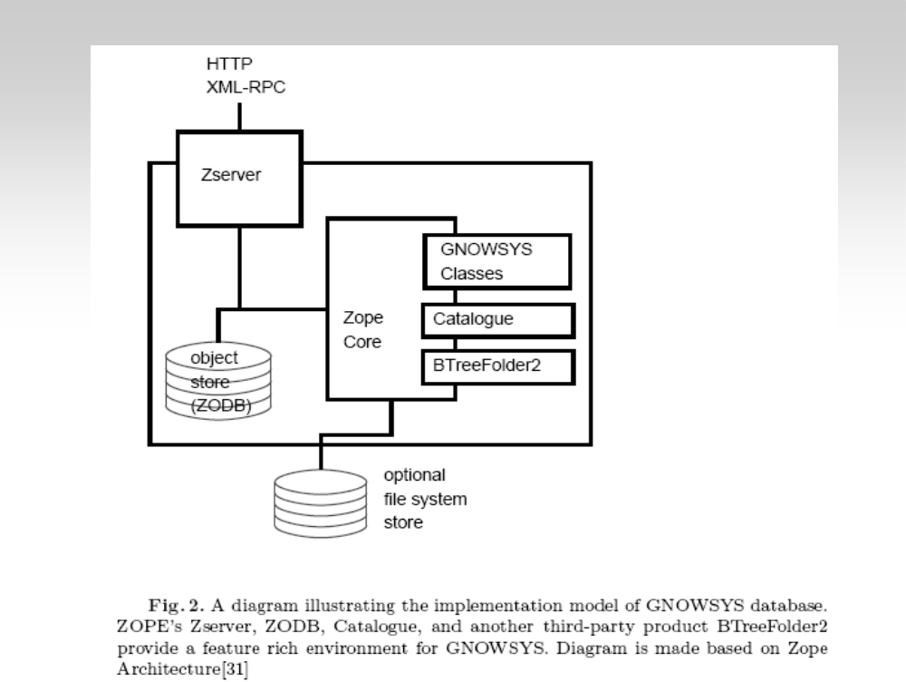

4.2.3.5 POSTGRESQL:

PostgreSQL is an object relational database management system (ORDBMS). It is released under a BSD style license and is thus free software. As with many other open-source programs, PostgreSQL is not controlled by any single company, but relies on a global community of developers and companies to develop it.
PostgreSQL is aimed to introduce the minimum number of features needed to add complete support for types. These features included the ability to define types, as well as the ability to fully describe relationships – something used widely before this time but maintained entirely by the user. In POSTGRES the database "understood" relationships, and could retrieve information in related tables in a natural way using rules.

PostgreSQL is a powerful, open source relational database system. It has more than 15 years of active development and a proven architecture that has earned it a strong reputation for reliability, data integrity, and correctness. It runs on all major operating systems, including Linux, UNIX and Windows. It has full support for foreign keys, joins, views, triggers, and stored procedures (in multiple languages). It includes most SQL data types, including INTEGER, NUMERIC, BOOLEAN, CHAR, VARCHAR, DATE, INTERVAL, and TIMESTAMP. It also supports storage of binary large objects, including pictures, sounds, or video. It has native programming interfaces for C/C++, Java, .Net, Perl, Python, Ruby, Tcl, ODBC, among others.
It is highly scalable both in the sheer quantity of data it can manage and in the number of concurrent users it can accommodate. There are active PostgreSQL systems in production environments that manage in excess of 4 terabytes of data. Some general PostgreSQL limits are included in the table below.
LimitValueMaximum Database SizeUnlimitedMaximum Table Size32 TBMaximum Row Size1.6 TBMaximum Field Size1 GBMaximum Rows per TableUnlimitedMaximum Columns per Table250 - 1600 depending on column typesMaximum Indexes per TableUnlimited
Other advanced features include table inheritance, a rules systems, and database events. Table inheritance puts an object oriented slant on table creation, allowing database designers to derive new tables from other tables, treating them as base classes. Even better, PostgreSQL supports both single and multiple inheritances in this manner.
Just as there are many procedure languages supported by PostgreSQL, there are also many library interfaces as well, allowing various languages both compiled and interpreted to interface with PostgreSQL. There are interfaces for Java (JDBC), ODBC, Perl, Python, Ruby, C, C++, PHP just to name a few.
Best of all, PostgreSQL's source code is available under the most liberal open source license: the BSD license. This license gives the user the freedom to use, modify and distribute PostgreSQL in any form as he or she likea, open or closed source. Any modifications, enhancements, or changes the user makes are the users to do with as he or she pleases. As such, PostgreSQL is not only a powerful database system capable of running the enterprise; it is a development platform upon which to develop in-house, web, or commercial software products that require a capable RDBMS.

4.2.3.6 MOZILLA FIREFOX:

Mozilla Firefox is a free and open source web browser descended from the Mozilla Application Suite and managed by Mozilla Corporation. A Net Applications statistic put Firefox at 24.52% of the recorded usage share of web browsers as of March 2010[update], making it the second most popular browser in terms of current use worldwide after Microsoft's Internet Explorer. Other sources put Firefox's usage share between 20% and 32%.
To display web pages, Firefox uses the Gecko layout engine, which implements most current web standards in addition to several features which are intended to anticipate likely additions to the standards.
Latest Firefox features include tabbed browsing, spell checking, incremental find, live bookmarking, a download manager, private browsing, location-aware browsing (also known as "geolocation") based exclusively on a Google service and an integrated search system that uses Google by default in most localizations. Functions can be added through add-ons, created by third-party developers, of which there is a wide selection, a feature that has attracted many of Firefox's users.
Firefox runs on various versions of GNU/Linux, Mac OS X, Microsoft Windows and many other Unix-like operating systems. Its current stable release is version 3.6.3, released on April 1, 2010[update] Firefox's source code is free software, released under a tri-license GNU GPL/GNU LGPL/MPL.

Standards :
Mozilla Firefox implements many web standards, including HTML, XML, XHTML, MathML, SVG 1.1 (partial), CSS (with extensions), ECMAScript (JavaScript), DOM, XSLT, XPath, and APNG (Animated PNG) images with alpha transparency. Firefox also implements standards proposals created by the WHATWG such as client-side storage, and canvas element.
The results of the Acid3 test on Firefox 3.6 Firefox passes the Acid2 standards-compliance test from version 3.0. Firefox versions 3.6 and 3.7alpha4 do not pass the Acid3 test; they score 94/100 and 96/100 respectively.
Firefox also implements a proprietary protocol from Google called "safebrowsing" (used to exchange data related with "phishing and malware protection"), which is not an open standard.

Security :
Firefox uses a sandbox security model, and limits scripts from accessing data from other web sites based on the same origin policy. It uses SSL/TLS to protect communications with web servers using strong cryptography when using the HTTPS protocol. It also provides support for web applications to use smartcards for authentication purposes.
The Mozilla Foundation offers a "bug bounty" to researchers who discover severe security holes in Firefox. Official guidelines for handling security vulnerabilities discourage early disclosure of vulnerabilities so as not to give potential attackers an advantage in creating exploits.
Because Firefox generally has fewer publicly known unpatched security vulnerabilities than Internet Explorer (see Comparison of web browsers), improved security is often cited as a reason to switch from Internet Explorer to Firefox. The Washington Post reports that exploit code for critical unpatched security vulnerabilities in Internet Explorer was available for 284 days in 2006. In comparison, exploit code for critical security vulnerabilities in Firefox was available for 9 days before Mozilla shipped a patch to remedy the problem.
A 2006 Symantec study showed that although Firefox had surpassed other browsers in the number of vendor-confirmed vulnerabilities that year

through September, these vulnerabilities were patched far more quickly than those found in other browsers. Symantec later clarified their statement, saying that Firefox still had fewer security vulnerabilities than Internet Explorer, as counted by security researchers. As of March 19, 2010, Firefox 3.6 has no unpatched security vulnerabilities according to Secunia. Internet Explorer 8 has four unpatched security vulnerabilities, the worst being rated "moderately critical" by Secunia.
In October 2009 Microsoft's security engineers acknowledged that Firefox was vulnerable since February of that year due to a .NET Framework 3.5 SP1 Windows update that silently installed a buggy 'Windows Presentation Foundation' plug-in into Firefox. This vulnerability has since been patched by Microsoft.

Extensions
Extensions add new functionality to Mozilla applications such as Firefox, SeaMonkey and Thunderbird. They can add anything from a toolbar button to a completely new feature. They allow the application to be customized to fit the personal needs of each user if they need additional features, while keeping the applications small to download.
Extensions are different from plugins, which help the browser display specific content like playing multimedia files. Extensions are also different from search plugins, which plug additional search engines in the search bar.Setting up your environment
This article focuses on Firefox extensions, although it also applies to other Toolkit applications, such as Thunderbird.
The first thing you need to do is download a recent version of your application. You can get Firefox here. As was mentioned above, you need Firefox 1.5 or later, setup tips from this article will not work in earlier versions.
For further instructions, see Setting up extension development environment. Do read that page, it will save you many hours when developing and debugging your extension. In particular, you must set the javascript.options.showInConsole pref to true.

What this Extension Does
This extension adds an item called 'Hello World!' to the Tools Menu in Firefox. It's a good example of creating an extension that pops up a new window when you activate it.

Planning your extension :
You should plan what you need for your extension; we will use an example that provides a new menu option that creates a message in a window. The following files are required, choose your own names if you like (but if you change any names remember to update all references to them), except for the folders and files 'chrome.manifest' and 'install.rdf'.

Filename | Purpose
chrome.manifest | Tells Firefox where your chrome files are and what to do with them
install.rdf | The description file for your extension ("Install manifest")
overlay.xul | The file describing UI elements to add to the browser window
overlay.js | The file with scripts to run in the browser window
overlay.dtd | Contains translation for text string codes in overlay.xul
hello.dtd | Contains translation for the strings in hello.xul
overlay.css | Lets you adjust appearance of UI elements with CSS
hello.xul | The file describing the UI of the new window
helloworld@mozilla.doslash.org | A pointer to your extension files

Creating stub extension files :
As you should already know, extensions usually modify an application's UI ("chrome") and behavior by providing overlays to already existent windows/documents. Those overlays are a part of the extension's content package (content provider). Most extensions also have one or more locales and skins. (If you didn't know that, we advise you to read XUL Structure chapter from XULPlanet's XUL Tutorial and Configurable Chrome document).
This section describes what directory structure and what files are needed in order to make Firefox register your extension's files.
You can download the ZIP file with all necessary stub files and appropriate folder structure and skip to Registering your extension in the Extension Manager. It's recommended that you nonetheless read the below subsections, as they explain the function of each file in the package and provide links to other resources.

Folder structure :
Below is the folder structure we will use. You may use a different structure, as long as you also update your chrome. manifest (see below) accordingly. Create the following structure in the folder where you intend to develop your project:

helloworld/
chrome.manifest
install.rdf
content/
overlay.js
overlay.xul
hello.xul
locale/
en-US/
overlay.dtd
hello.dtd
skin/
overlay.css

The folders are traditionally named "content", "locale" and "skin", and you should follow the tradition. You may call the files inside those folders whatever you want (except chrome.manifest and install.rdf).

Note: This folder structure is for development, you'll need different folder structure when packaging your extension.

Stub files :
chrome.manifest

Recent versions of Firefox read a simple plaintext chrome.manifest file (instead of the old and confusing contents.rdf) to determine what packages and overlays your extension provides. The format of this file is described in the Chrome Registration document. In the following example we'll create a chrome.manifest file for our folder structure.
It looks like this (assuming your extension's package name is "helloworld"):

1 | content helloworld content/
2 | overlay chrome://browser/content/browser.xul
3 | chrome://helloworld/content/overlay.xul
4 | locale helloworld en-US locale/en-US/
5 | skin helloworld classic/1.0 skin/
6 | style chrome://global/content/customizeToolbar.xul
7 | chrome://helloworld/skin/overlay.css

What each line of the file does:

- Line 1 registers a content provider: it maps the contents of chrome://helloworld/content/ to the content folder.

- Line 2 registers an overlay for chrome://browser/content/browser.xul location, allowing you to modify Firefox's main window UI from your overlay.xul file.
- Line 3 registers a en-US locale provider.
- Line 5 registers a default skin provider.
- Line 7 applies to chrome://global/content/customizeToolbar.xul document (used, for example, when creating toolbar buttons). You could instead register an overlay and include the stylesheet in the overlay using the <?xml-stylesheet?> processing instruction.
Warning:
Don't forget the end slash at the end of the paths : "content/" works, whereas "content" doesn't. Also note that the package name ('helloworld' in this case) has to be all lowercase.
Note: This file will be a bit different when you create an XPI for your extension, see the Packaging section below.
overlay.xul (overlay.xul is a simple XUL overlay.)
A simple overlay looks like this:

1 | <?xml version="1.0"?>
2 | <?xml-stylesheet href="chrome://helloworld/skin/overlay.css"type="text/css"?>
3 | <!DOCTYPE overlay SYSTEM "chrome://helloworld/locale/overlay.dtd">
4 | <overlay id="helloworld-overlay" xmlns="http://www.mozilla.org/keymaster/gatekeeper/there.is.only.xul">
5 | <script src="overlay.js"/>
6 | <menupopup id="menu_ToolsPopup">
7 | <menuitem id="helloworld-hello" label="&helloworld;"  oncommand="Helloworld.onMenuItemCommand(event);"/>
8 | </menupopup>
9 | </overlay>

What each line of the file does:

- Line 1 is the XML declaration, specifying the version of XML being used. It can also be used to specify file's encoding, but that should seldom be needed, as you should put localizable strings in the DTD file.
- Line 2 is optional and can be used to apply a stylesheet to the base document.
- Line 3 is also optional, but recommended if you include any user-visible strings in your overlay. It is used to make your overlay localizable.
- Lines 4-5 define the root element of the overlay. It must be a XUL <overlay> element.
- Line 6 is optional and can be used to attach a JavaScript file to the base document. See next section for more information.
- Lines 8-10 add a menu item to the Tools menu in Firefox main window.

overlay.js

As you may know, JavaScript files are used to define application's behavior. An important issue you should be aware of is that all scripts that are loaded for a given document (the scripts used by the window itself, and scripts loaded from overlays to that document) share the same scope. This means you should use unique names for global identifiers in your extensions to avoid clashing with other extensions. It's usually accomplished by prefixing all global identifiers with the name of your extension or by putting most/all of your variables and functions in an object with an unique name.

Typical JavaScript file for an overlay looks like this:
var Helloworld = {
onLoad: function() {
// initialization code
this.initialized = true; },

onMenuItemCommand: function() {
window.open("chrome://helloworld/content/hello.xul", "", "chrome");
}
};

window.addEventListener("load", function(e){
Helloworld.onLoad(e);
}, false);

overlay.dtd

DTD files are used to make XUL/XBL/XHTML and other XML files in Mozilla chrome localizable. Basically, instead of hard-coding the strings in your XUL file, you use XML entities, which expand to the values declared in the DTD file referenced at the top of the XUL file.
It makes your extension localizable, because there may be a few different locale providers for your extension, and Mozilla is able to choose between them at run-time.
DTD files used for localization purposes consist of entity declarations like the one below:

<!ENTITY helloworld "Hello World!">

hello.dtd
This is the file for the new window.
<!ENTITY title.label "Hello World">
<!ENTITY separate.label "This is a separate window!">
<!ENTITY close.label "Close">

hello.xul

In addition to modifying existing windows, you can create new windows for your extensions. The UI of your own windows is also described in XUL files, but unlike overlays, the root element is a <window> or a <dialog>, and not <overlay>. Another difference from overlays is that you don't have to register each of new windows in chrome.manifest.

The example package includes file hello.xul, which is used to describe a simple window.
<?xml version="1.0"?>
<?xml-stylesheet href="chrome://global/skin/global.css" type="text/css"?>
<!DOCTYPE window SYSTEM "chrome://helloworld/locale/hello.dtd">

<window xmlns="http://www.mozilla.org/keymaster/gatekeeper/there.is.only.xul"
title="&title.label;">
<hbox align="center">
<description flex="1">&separate.label;</description>
<button label="&close.label;" oncommand="close();"/>
</hbox>
</window>

install.rdf

install.rdf file is used by the Extension Manager when installing an XPI file and when registering an extension at specified location. In Firefox 1.5 and later it's only used to provide EM metadata, such as extension's ID, version, description, author etc.

<?xml version="1.0"?>
<RDF xmlns="http://www.w3.org/1999/02/22-rdf-syntax-ns#"
xmlns:em="http://www.mozilla.org/2004/em-rdf#">

<Description about="urn:mozilla:install-manifest">

<em:id>helloworld@mozilla.doslash.org</em:id>
<em:name>Hello World (Firefox 1.5 or later edition)</em:name>
<em:version>1.0</em:version>
<em:description>Classic first extension from MozillaZine KB</em:description>
<em:creator>Nickolay Ponomarev</em:creator>
<!-- optional items -->
<em:contributor>A person who helped you</em:contributor>
<em:contributor>Another one</em:contributor>

<em:homepageURL>http://kb.mozillazine.org/Getting_started_with_extension_development</em:homepageURL>
<!-- em:optionsURL>chrome://sampleext/content/settings.xul</em:optionsURL>
<em:aboutURL>chrome://sampleext/content/about.xul</em:aboutURL>
<em:iconURL>chrome://sampleext/skin/mainicon.png</em:iconURL>

<em:updateURL>http://sampleextension.mozdev.org/update.rdf</em:updateURL-->

<!-- Firefox -->
<em:targetApplication>
<Description>
<em:id>{ec8030f7-c20a-464f-9b0e-13a3a9e97384}</em:id>
<em:minVersion>1.5</em:minVersion>
<em:maxVersion>2.0.0.*</em:maxVersion>
</Description>
</em:targetApplication>
</Description>
</RDF>

overlay.css

overlay.css is used by Firefox to apply a specific look to the extension component(s) you are installing. In this case, we want to color the helloworld menu item red.
/* This is just an example. You shouldn't do this. */
menuitem#helloworld-hello {
color: red !important; }

Registering your extension in the Extension Manager

Before releasing your extension to the public you must thoroughly test it. To avoid problems during this phase it is advisable to create and use a new profile for testing it.

Once you have created the files described above and have placed them in the appropriate folder structure, registering them in the Extension Manager is trivial. With Firefox closed, create a "pointer" file with the same name as your extension's ID in profile folder/extensions/ and edit it so that it contains the path to your folder containing install.rdf and chrome.manifest files.

E.g. helloworld's ID is helloworld@mozilla.doslash.org and we would like to register it in X:\Dev\helloworld\ (i.e. there is X:\Dev\helloworld\install.rdf file etc.). Just put a single line into the file at this path: profile folder/extensions/helloworld@mozilla.doslash.org

X:\Dev\helloworld

Start Firefox, and check that your extension is installed. Then test it.

Development cycle

Once you have registered your extension following the steps above, developing your extension is quite easy. If you've set the development preferences, your development cycle will be like this:

- Edit your extension files.

- Reopen the window(s) that modified files apply to, or use Reload chrome feature of Extension Developer Extension. Because the Reload Chrome feature of the Extension Developer Extension does not work for Thunderbird, you can alternately use the Reloadchromezilla extension for Thunderbird and Firefox 1.5.

- If you changed chrome.manifest, you'll have to restart.

- If you changed install.rdf, you need to touch the extension folder specified in your "pointer" file (update its Last modified time) and restart.

(i.e. If you update c:\dev\helloworld\install.rdf you need to make sure the folder c:\dev\helloworld has a different timestamp.

A quick way to do this on windows is to rename c:\dev\helloworld to c:\dev\helloworld-tmp, make a new helloworld folder, then copy the contents of the helloworld-tmp folder into the new helloworld folder. Alternatively, display the folder in Explorer, right click on the right hand side pane, and select New>Folder - then just delete the New Folder.
(on linux you could just use the touch command.)
It's much more convenient compared to the edit-rezip-restart cycle many extension authors were using or the pleasure of editing chrome.rdf file or similar setup tricks.

Packaging

As it was mentioned, the folder structure and chrome.manifest file must be changed before packaging. Compare:

Developing | Packaging
Folder structure
helloworld/  chrome.manifest  install.rdf  components/  defaults/  preferences/  mydefaults.js  content/  overlay.js  overlay.xul  locale/  en-US/  overlay.dtd  skin/  overlay.css | helloworld.xpi/  chrome.manifest  install.rdf  components/  defaults/  preferences/  mydefaults.js  chrome/  helloworld.jar  content/  overlay.js  overlay.xul  locale/  en-US/  overlay.dtd  skin/  overlay.css
chrome.manifest (note extra "jar:chrome/helloworld.jar!/" in the right column)
content helloworld content/  overlay chrome://browser/content/browser.xul chrome://helloworld/content/overlay.xul  locale helloworld en-US locale/en-US/  skin helloworld classic/1.0 skin/  style chrome://global/content/customizeToolbar.xul chrome://helloworld/skin/overlay.css | content helloworld jar:chrome/helloworld.jar!/content/  overlay chrome://browser/content/browser.xul chrome://helloworld/content/overlay.xul  locale helloworld en-US jar:chrome/helloworld.jar!/locale/en-US/  skin helloworld classic/1.0 jar:chrome/helloworld.jar!/skin/  style chrome://global/content/customizeToolbar.xul chrome://helloworld/skin/overlay.css

Packaging your chrome files into a JAR file brings some benefits such a smaller download size however it also introduces unnecessary complexity and for many starting out it is generally easier to not use JAR files.
Some links and tools are available at Packaging extensions.

PyXPCOM allows for communication between Python and XPCOM, such that a Python application can access XPCOM objects, and XPCOM can access any Python class that implements an XPCOM interface. With PyXPCOM, a developer can talk to XPCOM or embed Gecko from a Python application. PyXPCOM is similar to JavaXPCOM (Java-XPCOM bridge) or XPConnect (JavaScript-XPCOM bridge).

Python classes and interfaces: Mozilla defines many external interfaces available to embeddors and component developers. PyXPCOM provides access to these interfaces as Python interfaces. PyXPCOM also contains several classes that provide access to functions for initializing and shutting down XPCOM and Gecko from Python, as well as some XPCOM helper functions.

4.2.3.7 Python XPCOM Package Architecture:

Much of the design for the Python XPCOM Package has been borrowed from the Python MS-COM extensions in win32com. Most of the major limitations and drawbacks in the win32com design have been addressed, mainly "auto-wrapping" of interface objects, which is not supported by win32com.

Like win32com, this architecture includes the concept of client COM and server COM.

Client COM:
- calls other interfaces
- is supported by PyInterfaces implemented in C++, which assists in making the COM calls

- is supported by PyGateways, which assists in receiving external COM calls and dispatching them to the correct Python object
- is supported in the xpcom/client package

Server COM:

- implements interfaces for use by other XPCOM applications or components
- is supported in the xpcom/server package
- The XPConnect framework is very powerful, and far exceeds what COM's IDispatch can offer. Thus, we are able to get by with far fewer interfaces supported in the C++ level, and defer most things to the Python code that uses XPConnect. As a result, the requirement for a huge number of interfaces to exist in the .pyd does not exist. There are, however, a number of interfaces that do require native C++ support: these are interfaces required to "boot" the XPConnect support (i.e., the interfaces that are used to get information about interfaces),

and also two gateways that need to work without interface information available. This last requirement is due to the XPCOM shutdown-ordering - it may be a bug, but is not an unreasonable amount of code anyway.
- Auto-wrapping of COM objects is supported by both client COM and server COM. For client COM, auto-wrapping means that the Python programmer always sees Python "component" objects, rather than raw C++ interface objects; to the user, it all appears to "just work". This is a major source of frustration in the win32com framework.
- For server COM, auto-wrapping means that you can pass Python instances wherever a COM object is expected. If the Python instance supports COM interfaces, by virtue of having a _com_interfaces_ attribute that lists the interface requested, it will be automatically wrapped in the correct COM object.

Error Handling:

The C++ framework has good error handling support, and uses the XPCOM console service to log debug messages, Python exceptions and tracebacks. win32com does not have good exception/traceback support at the C++ level, mainly because COM does not define a service like the console where debug messages can go. This does mean that in Mozilla release builds, these debug messages are likely to be lost, but the --console command line option to a release Mozilla will get them back. Therefore, the other error-support utilities, such as the error callbacks made on the policy object, may be used.

Component Loader, Modules and Factories:

XPCOM has the concept of a component loader - a module used to load all components of a particular type. For example, the moz.jsloader.1 component loads all the JavaScript components. Similarly, the moz.pyloader.1 component loads all Python components. However, unlike JavaScript, the Python component loader is actually implemented in Python itself! Since the Python component loader can not be used to load itself, this component has some special code, pyloader.dll, to boot-strap itself.

This means is that all XPCOM components, including the Python loader itself and all XPCOM module and factory interfaces, are implemented in Python. There are no components or interfaces implemented purely in C++ in this entire package!

Python XPCOM Package Tutorial

This is a quick introduction to the Python XPCOM Package. We assume that you have a good understanding of Python and XPCOM, and have experience both using and implementing XPCOM objects in some other language (e.g., C++ or JavaScript). We do not attempt to provide a tutorial to XPCOM or Python itself, only to using Python and XPCOM.

This tutorial contains the following sections:
Using XPCOM Objects and Interfaces - when you wish to use a component written by anyone else in any XPCOM supported language.
Implementing XPCOM Objects and Interfaces - when you wish to implement a component for use by anyone else in any xpcom supported language.
Parameters and Types - useful information regarding how Python translates XPCOM types and handles byref parameters.
For anything not covered here, try the advanced documentation, and if that fails, use the source, Luke.

Using XPCOM object and interfaces:

The techniques for using XPCOM in Python have been borrowed from JavaScript - thus, the model described here should be quite familiar to existing JavaScript XPCOM programmers.

xpcom.components module

When using an XPCOM object, the primary module used is the xpcom.components module. Using this module, you can get a Python object that supports any scriptable XPCOM interface. Once you have this Python object, you can simply call XPCOM methods on the object, as normal.

The xpcom.components module defines the following public members:

Name | Description
classes | A mapping (dictionary-like object) used to get XPCOM "classes". These are indexed by XPCOM contract ID, just like the JavaScript object of the same name.  Example:  cls = components.classes["@mozilla.org/sample;1"]  ob = cls.createInstance() # Now have an nsISupports
interfaces | An object that exposes all XPCOM interface IDs (IIDs). Like the JavaScript object of the same name, this object uses "dot" notation, as demonstrated below.  Example:  ob = cls.createInstance(components.interfaces.nsISample)  # Now have an nsISample

For many people, this is all you need to know. Consider the Mozilla Sample Component. The Mozilla Sample Component has a contract ID of @mozilla.org/sample;1, and implements the nsISample interface.
Thus, a complete Python program that uses this component is shown below.

from xpcom import components
cls = components.classes["@mozilla.org/sample;1"]
ob = cls.createInstance(components.interfaces.nsISample)
# nsISample defines a "value" property - let's use it!
ob.value = "new value"
if ob.value != "new value":
print "Eeek - what happened?"

And that is it - a complete Python program that uses XPCOM.

Implementing XPCOM Objects and Interfaces.

Implementing XPCOM objects is almost as simple as using them. The basic strategy is this:

Create a standard Python source file, with a standard Python class.
Add some special attributes to your class for use by the Python XPCOM framework. This controls the XPCOM behavior of your object.
Implement the XPCOM properties and methods of your classes as normal.
Put the Python source file in the Mozilla components directory.
Run regxpcom.
Your component is now ready to be used.

Attributes

There are two classes of attributes: those used at runtime to define the object behavior and those used at registration time to control object registration. Not all objects require registration, thus not all Python XPCOM objects will have registration-related attributes.

Attribute | Description
_com_interfaces_ | The interface IDs (IIDs) supported by the component. For simplicity, this may be either a single IID, or a list of IIDs. There is no need to specify base interfaces, as all parent interfaces are automatically supported. Thus, it is never necessary to nominate nsISupports in the list of interfaces.  This attribute is required. Objects without such an attribute are deemed unsuitable for use as a XPCOM object.
_reg_contractid_ | The contract ID of the component. Required if the component requires registration (i.e., exists in the components directory).
_reg_clsid_ | The Class ID (CLSID) of the component, as a string in the standard "{XXX-XXX-XXX-XXX}" format. Required if the component requires registration (i.e., exists in the components directory).
_reg_registrar_ | Nominates a function that is called at registration time. The default is for no extra function to be called. This can be useful if a component has special registration requirements and needs to hook into the registration process.
_reg_desc_ | The description of the XPCOM object. This may be used by browsers or other such objects. If not specified, the contract ID is used.

Properties
A Python class can support XPCOM properties in one of two ways. Either a standard Python property of the same name can exist - our sample component demonstrates this with the boolean_value property. Alternatively, the class can provide the get_propertyName(self) and set_propertyName(self, value) functions (with propertyName changed to the appropriate value for the property), and these functions will be called instead.
Example: The Python XPCOM Test Component
As an example, examine the Python XPCOM Test Component. This code can be found in py_test_component.py.
from xpcom import components

class PythonTestComponent:
_com_interfaces_ = components.interfaces.nsIPythonTestInterface
_reg_clsid_ = "{7EE4BDC6-CB53-42c1-A9E4-616B8E012ABA}"
_reg_contractid_ = "Python.TestComponent"
def __init__(self):
self.boolean_value = 1
...
def do_boolean(self, p1, p2):
ret = p1 ^ p2
return ret, not ret, ret
...

Type Conversion Rules: This component only specifies the mandatory attributes - _com_interfaces, _reg_clsid_ and _reg_contractid_.
This sample code demonstrates supporting the boolean_value attribute, supported implicitly, as it is defined in the IDL and exists as a real Python attribute of that name, and a method called do_boolean.
Tip: The xpcom/xpt.py Script

The xpcom/xpt.py script is a useful script that can generate the skeleton of a class for any XPCOM interface. Just specify the interface name on the command-line, and paste the output into your source file.
This is the output of running this program over the nsISample interface (i.e., assuming we wanted to implement a component that supported this interface):

class nsISample:
_com_interfaces_ = xpcom.components.interfaces.nsISample

# If this object needs to be registered, the following 2 are also needed.
# _reg_clsid_ = {a new clsid generated for this object}
# _reg_contractid_ = "The.Object.Name"

def get_value( self ):
# Result: string
pass
def set_value( self, param0 ):
# Result: void - None
# In: param0: string
pass
def writeValue( self, param0 ):
# Result: void - None
# In: param0: string
pass
def poke( self, param0 ):

# Result: void - None
# In: param0: string
pass

Note: The types of the parameters and the function itself are included in the comments. You need to implement the functions themselves. Another advantage of this script is that the hidden parameters are handled for you; the comments indicate when parameters have been hidden.

Parameters and Types
This section briefly describes the XPCOM type support in Python.
All XPCOM interfaces define parameters of a specific type. There is currently no concept of a variant, or union of all types.

Thus, the conversion rules are very straightforward, and generally surprise free: for any given XPCOM method, there is only one possible type for a given parameter.
Note:
All numeric types will attempt to be coerced to the correct type. Thus, you can pass a Python float to an XPCOM method expecting an integer, or vice-versa. Specifically, when an integer is required, you can pass any Python object for which int() would succeed; for a Python float, any object for which float() would succeed is acceptable. This means that you can pass a Python string object as an integer, as long as the string was holding a valid integer. Strings and Unicode objects are interchangeable, but no other automatic string conversions are performed. Thus, you can not pass an integer where a string is expected, even though the reverse is true.

Any sequence object can be passed as an array. List objects are always returned for arrays. Any Python instance suitable for use as a XPCOM object (i.e., with the necessary annotations) can be passed as a XPCOM object. No special wrapping step is needed to turn a Python instance into a XPCOM object. Note you must pass a class instance, not the class itself. Many XPCOM method signatures specify "count" or "size" parameters. For example, every time an array is passed via XPCOM, the method signature will always specify an integer that holds the count of the array. These parameters are always hidden in Python. As the size param can be implied from the length of the Python sequence passed, the Python programmer need never pass these parameters; in contrast, JavaScript requires these redundant parameters.

4.2.3.8 XPI Firefox

The package contains a JavaScript install script (install.js) with some directives for actions to take during an install, including adding files and directories, removing old or obsolete files and directories, executing command line tools, etc. In more recent Firefox and Thunderbird versions, the install script has been replaced by a chrome manifest and a RDF file (install.rdf).

4.2.3.9 XUL Firefox

In computer programming, XUL (pronounced zool ([zu:l])), the XML User Interface Language, is an XML user interface markup language developed by the Mozilla project which operates in Mozilla cross-platform applications such as Firefox.
XUL relies on multiple existing web standards and technologies, including CSS, JavaScript, and DOM. Such reliance makes XUL relatively easy to learn for people with a background in web-programming and design.

Mozilla provides experimental XULRunner builds to let developers build their applications on top of the Mozilla application framework and XUL in particular.

XUL provides a portable definition for common widgets, allowing them to move easily to any platform on which Mozilla applications run.[3]

4.2.3.10 XML-RPC Specification and Advantages

An XML-RPC call is conducted between two parties: the client (the calling process) and the server (the called process). A server is made available at aparticular URL ( for
example , http://example.org:8080/rpcserv/).

To use the procedures available on that server, the following steps are necessary:
That is, an HTTP server responding on port 8080, on the machine whose name is example.org.

1. The client program makes a procedure call using the XML-RPC client, specifying a method name, parameters, and a target server.

2. The XML-RPC client takes the method name and parameters and then packages them as XML. Then the client issues an HTTP POST request containing the request information to the target server.

3. An HTTP server on the target server receives the POST request and
passes the XML content to an XML-RPC listener.

4. The XML-RPC listener parses the XML to get the method name and
parameters and then calls the appropriate method, passing it the
parameters.

5. The method returns a response to the XML-RPC process and the XML- RPC process packages the response as XML.

6. The web server returns that XML as the response to the HTTP POST request.

7. The XML-RPC client parses the XML to extract the return value and
then passes the return value back to the client program.

8. The client program continues processing with the return value.

There is nothing to stop a process from being both a server and a client, making and receiving XML-RPC requests. It is important, however, to recognize that in any single XML-RPC request, there are always the two roles of client and server. The use of HTTP means that XML-RPC requests must be both synchronous and stateless.

Synchronous

An XML-RPC request is always followed by exactly one XML-RPC response; the response is synchronous with the request. This happens because the response must occur on the same HTTP connection as the request. Furthermore, the client process blocks (waits) until it receives a response from the server.

This step has consequences for program design: your code should be written in such a way that the potential blocking of a response for some time will not affect its operation, or else your program should restrict itself to calling remote methods that execute in "reasonable" time. "Reasonable" may vary, according to the needs of your program. Methods that are called frequently in time-sensitive environments
may be unreasonable if they take more than a fraction of a second; methods that are
called occasionally to return large volumes of information may be perfectly
reasonable even if they take a few minutes to return the full collection of
information requested.

Systems that require asynchronous responses can build such systems on the
synchronous foundation of XML-RPC using multiple request-response cycles. One
simple way forward would be to have the server process return a unique identifier
and the calling process implement a special XML-RPC method that allows the
transmission of results corresponding with the request. If the transactions are
conducted over the Internet, this also means that both processes must be accessible
through any firewall that might be in place. In general, synchronous requests are
capable of fulfilling many processes' requirements, and the overhead of creating an
asynchronous system is probably prohibitive in most cases.

5.DESIGN

5.1 UML DIAGRAMS

5.1.1 SEQUENCE DIAGRAMS

- LOGIN

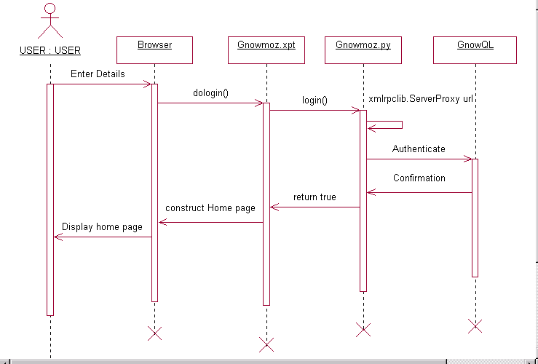
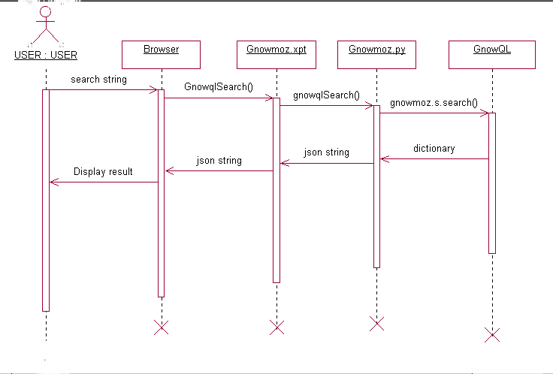
- SEARCH

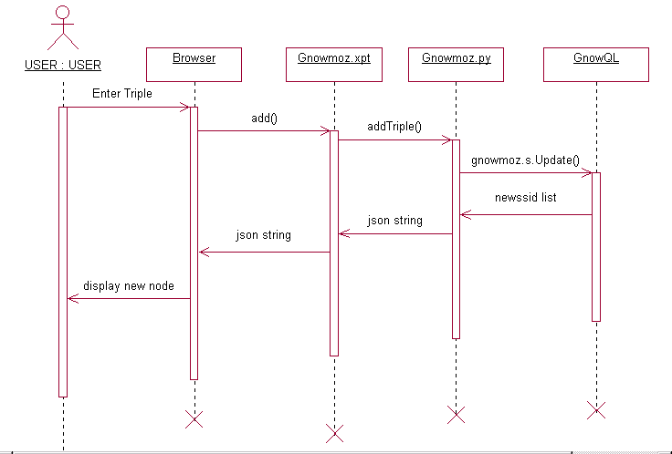
- ADD

5.2 INTERFACE DESIGN

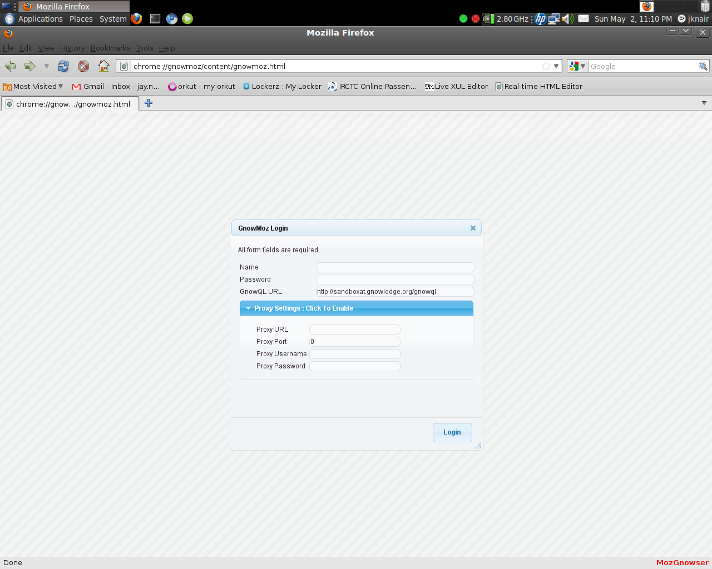

This is the Login page which is the first page of the MozGnowser extension. A valid and registered user can login using LOGIN ID and PASSWORD. Once the user is authenticated then home page will be displayed. If direct Internet connection is not available the user can also login by specifying the proxy settings.

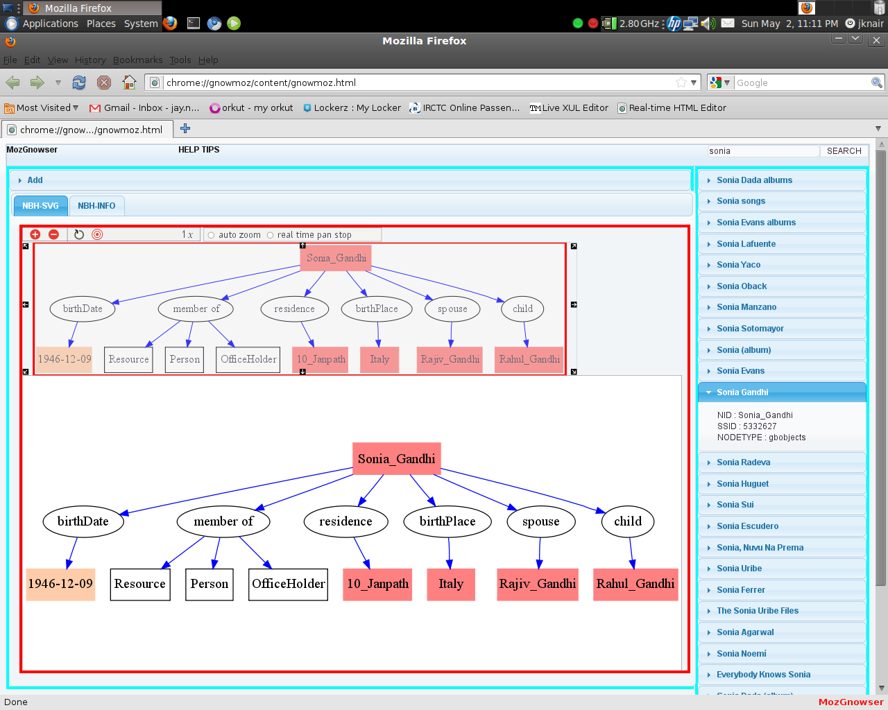

This page shows the functioning of the search function. A user can search for a value by entering the required value name in the textbox. Auto-complete feature is enabled. This feature will be enabled only after typing 3 letters in the textbox to reduce flooding of data. If the value is present in the database then the resulting SVG will be displayed otherwise the output will be No Result. For example, in this snapshot the user has searched for the value Sonia and the resulting SVG is displayed.

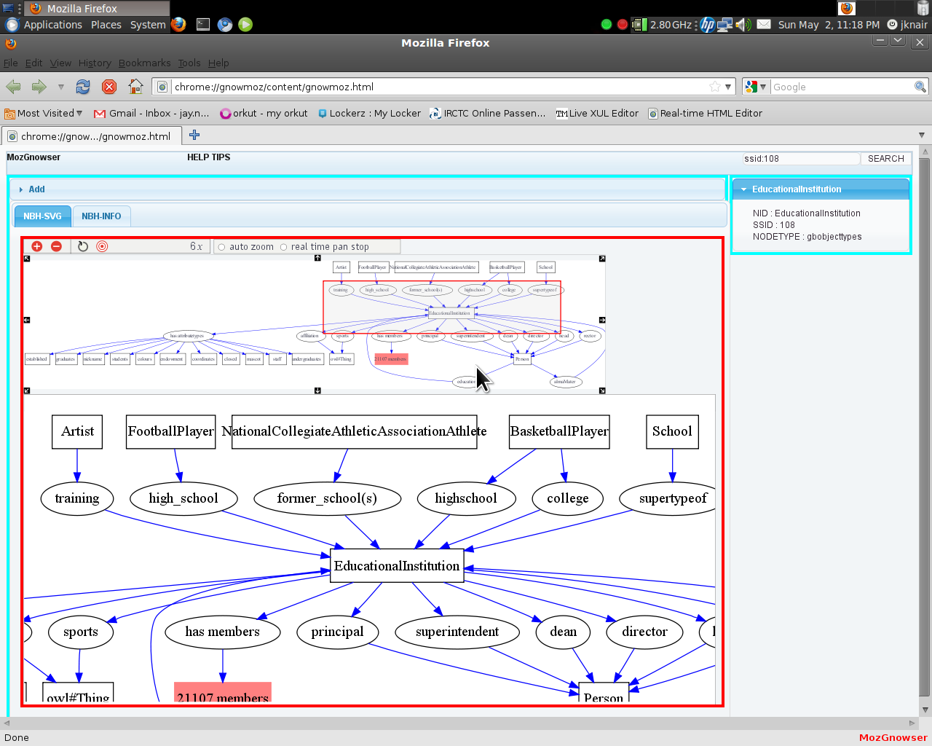

If the user is acquainted with the Gnowsys system, then the user can search for a particular node by specifying the ssid of the node itself in the following format:
eg: “ssid:108”
The page even shows autozoom functionality for the SVG image. If the svg is too big, the user can use the zoom function to view the image clearly. The shortcuts for autozoom are as follows:

Ctrl + z: Zoom in
Ctrl + x: Zoom out
Ctrl + arrows: Panning

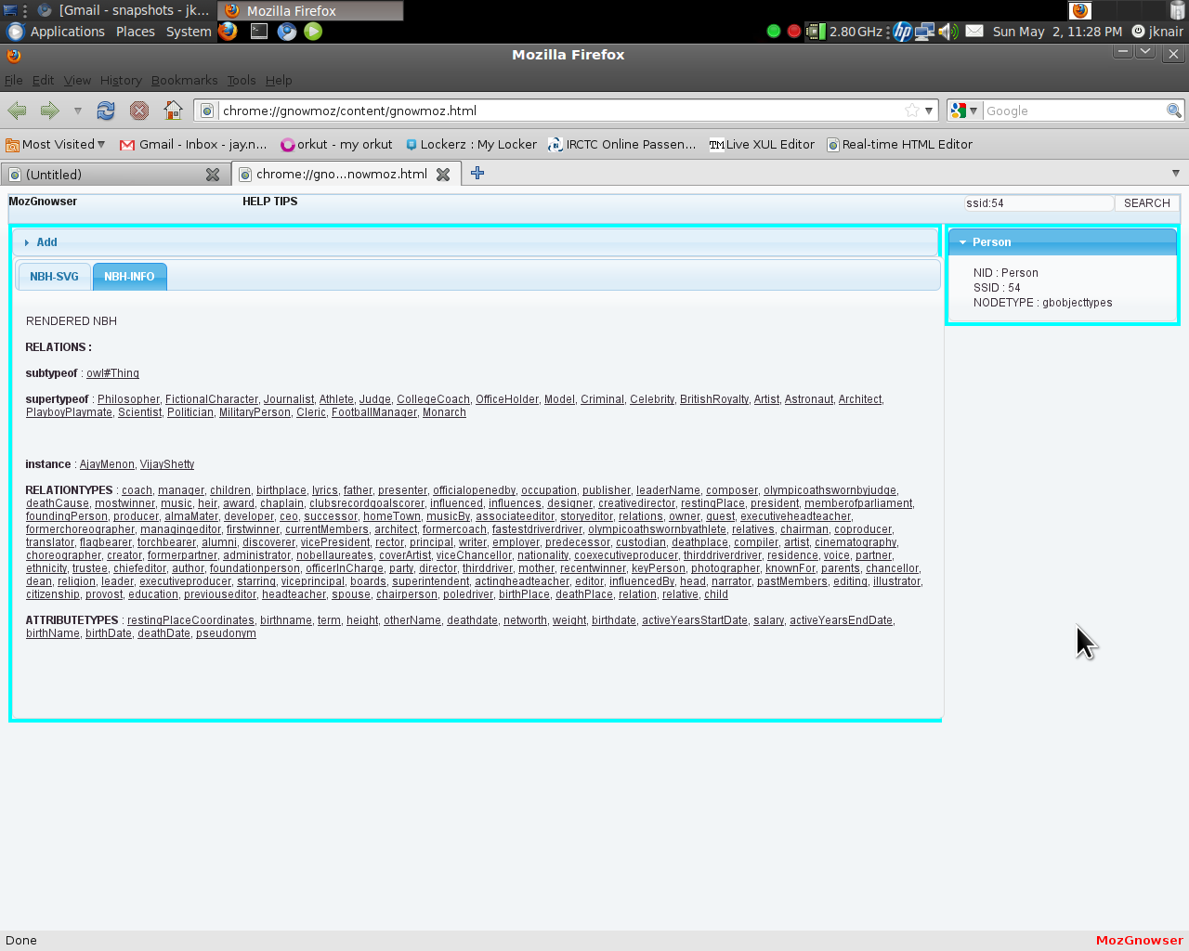

When the images are too large and difficult to view, then they can be viewed in textual format which is shown in NBH-INFO tab.
5.3 ARCHITECHTURE
The project deals with creating a complete GUI interface for enabling all users of various fields that would be benefited by Gnowledge networking.
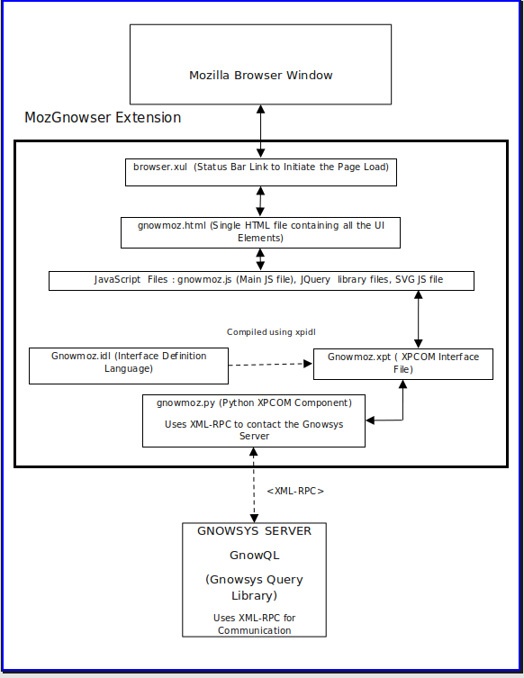

- browser.xul :
This file contains the XUL code that places a link on the status bar of the browser that loads the gnowmoz.html page from the location chrome://gnowmoz/content/gnowmoz.html

- gnowmoz.html :
This file contains all the html content of the whole
application which is loaded when the MozGnowser link is clicked on the status bar.

- JavaScript Files :
- Jquery.js , jquery-ui.js , jquery.qtip.js , jquery.hotkeys.js:
These files are the jquery files for building the ui and necessary key bindings and small ui plugins like tooltips for the interface.

- Json2.js :
This file is used as json parser to make the json variable to a javascript object for organizing the data received from the python interface to the Gnowsys Server

- Zoom.js :
This file is part of the SVG autozoom feature which enables the various features on the SVG for zooming and panning of the resultant SVG obtained from the Gnowsys Server.

- Gnowmoz.js :
This file is the main javascript file which is used to connect to the gnowmoz.xpt PyXPCOM interface and has all the main functions that control the whole application.
It contains all the functions for various operations like:
- Login is done using the dologin() function
- Search is done using GnowqlSearch() function
- Addition of nodes is done using addTriple() function

6.TESTING AND MAINTENANCE:

Once the code has been generated, program testing begins. The testing process focuses on logical internals of the software ,ensuring that all statements have been tested and all the functional externals, i.e. conducting tests to uncover errors and ensure that defined input will produce the actual results that agree with the required results. The different forms of program testing are as follows:

- White Box testing
- Black Box testing
- Module testing
- Integration and Regression testing

White box testing:
White box testing (a.k.a. clear box testing, glass box testing, transparent box testing or structural testing) uses an internal perspective of the system to design test cases based on internal structure. It requires programming skills to identify all paths through the software. The tester chooses test case inputs to exercise paths through the code and determines the appropriate outputs. In electrical hardware testing, every node in a circuit may be probed and measured; an example is in-circuit testing (ICT).
Since the tests are based on the actual implementation, if the implementation changes, the tests probably will need to change, too. For example ICT needs updates if component values change, and needs modified/new fixture if the circuit changes. This adds financial resistance to the change process, thus buggy products may stay buggy. Automated optical inspection (AOI) offers similar component level correctness checking without the cost of ICT fixtures, however changes still require test updates.
While white box testing is applicable at the unit, integration and system levels of the software testing process, it is typically applied to the unit. While it normally tests paths within a unit, it can also test paths between units during integration, and between subsystems during a system level test. Though this method of test design can uncover an overwhelming number of test cases, it might not detect unimplemented parts of the specification or missing requirements, but one can be sure that all paths through the test object are executed.
Typical white box test design techniques include:
- Control flow testing
- Data flow testing
- Branch testing
- Path testing

Black-box testing:
Black box testing uses external descriptions of the software, including specifications, requirements, and design to derive test cases. These tests can be functional or non-functional, though usually functional. The test designer selects valid and invalid inputs and determines the correct output. There is no knowledge of the test object's internal structure.
This method of test design is applicable to all levels of software testing: unit, integration, functional testing, system and acceptance. The higher the level, and hence the bigger and more complex the box, the more one is forced to use black box testing to simplify. While this method can uncover unimplemented parts of the specification, one cannot be sure that all existent paths are tested.

Testing levels:
Tests are frequently grouped by where they are added in the software development process, or by the level of specificity of the test.

Unit testing
Unit testing refers to tests that verify the functionality of a specific section of code, usually at the function level. In an object-oriented environment, this is usually at the class level, and the minimal unit tests include the constructors and destructors. These types of tests are usually written by developers as they work on code (white-box style), to ensure that the specific function is working as expected. One function might have multiple tests, to catch corner cases or other branches in the code. Unit testing alone cannot verify the functionality of a piece of software, but rather is used to assure that the building blocks the software uses work independently of each other.
Validation Testing
TEST CASE FOR LOGIN

INPUT | EXPECTED OUTPUT
INVALID USERNAME | LOGIN INCORRECT
INVALID PASSWORD | LOGIN INCORRECT
INVALID USERNAME AND PASSWORD | LOGIN INCORRECT

TEST CASE FOR SEARCH

INPUT | EXPECTED OUTPUT
Searched value entered which exists on the Gnowsys database. | Proper result obtained.
Searched value entered which does not exist on the Gnowsys database. | Displays no result in the output.
When ssid: <no> is entered in the correct syntax. | Gets proper result according to the ssid.
When ssid: <no> is not entered in the correct syntax. | Displays no result in the output.

TEST CASE FOR SVG

INPUT | EXPECTED OUTPUT
Links clicked on SVG elements. | Redirects to the page of the link clicked
When clicked outside the SVG elements. | No response.

System testing
System testing of software or hardware is testing conducted on a complete, integrated system to evaluate the system's compliance with its specified requirements. System testing falls within the scope of black box testing, and as such, should require no knowledge of the inner design of the code or logic.
MozGnowser has been tested on the following operating system:
http://pyxpcomext.mozdev.org/downloads.html
- Ubuntu Linux 9.10 (both 32-bit and 64-bit operating system).
- Windows XP, Windows Vista, Windows 7.
- Mac OSX Snow Leopard.
With Mozilla Firefox (3.5 & 3.6) using the following choice of packages:

Mozilla 1.9.2 (Firefox 3.6, XULRunner 1.9.2) - Alpha release
- Windows platform (x86). Note: requires that both the Microsoft Visual Studio 2005 and 2008 C++ runtimes be installed.
- Linux x86 platform (x86 libc6)
- Linux x86_64 platform (x86_64 libc6)
- Mac OS X (x86 - Intel)

Mozilla 1.9.1 (Firefox 3.5, XULRunner 1.9.1, Thunderbird 3.0)
- Windows platform (x86). Note: requires that both the Microsoft Visual Studio 2005 and 2008 C++ runtimes be installed.
- Linux x86 platform (x86 libc6)
- Linux x86_64 platform (x86_64 libc6)
- Mac OS X (universal build)

Mozilla 1.9.0 (Firefox 3.0, XULRunner 1.9.0)
- Windows platform (x86). Note: requires that the Microsoft Visual Studio 2005 runtime is installed.
- Linux x86 platform (x86 libc version 6)
- Mac OS X (universal build)

Mozilla 1.8 (Firefox 2, Thunderbird 2)
- Windows platform (x86)
- Linux x86 platform (x86 libc version 5, UCS4 Python build)
- Mac OS X (universal build)

Alpha testing
Alpha testing is simulated or actual operational testing by potential users/customers or an independent test team at the developers' site. Alpha testing is often employed for off-the-shelf software as a form of internal acceptance testing, before the software goes to beta testing.
MozGnowser has been tested on the local installation of Gnowsys server and has been implemented successfully.

7. BIBLIOGRAPHY

REFERENCES:

XPCOM:
https://developer.mozilla.org/En

https://developer.mozilla.org/en/PyXPCOM

https://developer.mozilla.org/en/XPCOM

https://developer.mozilla.org/en/IDL_interface_rules

https://developer.mozilla.org/en/Code_snippets/File_I//O

http://public.activestate.com/pyxpcom/index.html

http://pyxpcomext.mozdev.org/no_wrap/tutorials/pyxulrunner/python_xulrunner_about.html

http://hyperstruct.net/2006/8/10/your-first-javascript-xpcom-component-in-10-minutes

SVG:
http://www.dotuscomus.com/svg/lib/library.html
http://www.unet.univie.ac.at/~a9900479/svg4tom/svg4tom1.html#

JS :
http://www.json.org/js.html

http://jqueryui.com/

http://jquery.com/

http://code.google.com/p/js-hotkeys/

http://github.com/jeresig/jquery.hotkeys/blob/master/jquery.hotkeys.js

http://craigsworks.com/projects/qtip/

http://github.com/dustmoo/qtip/blob/master/jquery.qtip-1.0.0-rc3-dm-min.js

Python:

https://developer.mozilla.org/En/Creating_a_Python_XPCOM_component

http://docs.python.org/library/xmlrpclib.html

http://roshansingh.wordpress.com/2009/10/25/proxy-in-xmlrpclib/

http://docs.python.org/library/json.html

http://docs.python.org/library/urllib2.html

http://docs.python.org/library/xml.dom.html

Gnowsys

http://lab.gnowledge.org/

http://savannah.gnu.org/projects/gnowsys

http://lab.gnowledge.org/Software/gnowsys_rc1

http://gnowledge.org/cgi-bin/mailman/listinfo/gnowsys-dev

